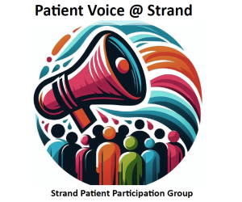

Minutes of Meeting held on Tuesday 2 December, 2025
Present: Anne, , Julian, Anita, Justin, , Garry, Graeme, Dr Craughan
- Welcome
Anne welcomed everyone to the meeting.

- Apologies: Elaine, Alison
- Practice News { changed order as Dr Craughan needed to leave}
Dr Craughan gave an update on Klinik and how it was evolving.They can now predict demands, with Monday being very busy. All Klinik forms are seen by one doctor. Urgent cases are seen on the day and routine within 2 weeks.
Justin used AI to produce a breakdown and it is included below.

- Minutes of last meeting
These were approved.

- Matters arising not dealt with elsewhere.
None

- Planning for next year
- Awareness Week: No date has been decided but there was discussion about changing the hours members were present in the afternoon.
- It was agreed that members would research information about a certain topic e.g. diabetes which could be used on our noticeboard and webpage.
- Graeme reported on access problems for disabled people on pavements throughout Worthing and he was asked by Anne to draw up a list of particular dangers and she would forward this to Sophie Cox.
- Garry proposed using our webpage more to highlight relevant information.
- The information on CPR Training has now been handed to the surgery and Lorraine has contacted the providers.
- Anita aimed to add links to online training for CPR and First Aid.
- Discussion followed on how to engage with younger people and ethnic minorities.
- A Junior PPG has been set up by West Sussex ICB.
- Perhaps we could arrange an event on a Saturday morning with staff there to discuss Asthma, Mole checking and mental health.

- Practice News
As of 1st October there was a new GP Contract.
Claire Waite a 3rd year trainee was working at the surgery.
Covid/Flu clinics were starting on 8 October.

- A.O.B
- Graeme reported that Action for Deafness had closed down but only over 55s were being transferred to Specsavers. He would ask what he should do when he goes to the hospital the following day. Hearing aid batteries are available at the surgery.
- It was suggested that we put a poster on our noticeboard asking people if they would be interested in what we do and would like to come to our next meeting.

- Date of next meeting:. Tuesday 2 December at 6.30pm

