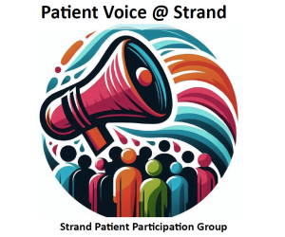

Minutes of Meeting held on Tuesday 2 December, 2025
Present: Anne, Julian, Anita, Justin, Garry, Graeme, Dr Craughan
- Welcome
Anne welcomed everyone to the meeting.

- Apologies: Elaine, Alison

- Practice News { changed the order as Dr Craughan needed to leave}
Dr Craughan gave an update on Klinik and how it was evolving. The surgery can now predict demands, with Monday being very busy. All Klinik forms are seen by one doctor. Urgent cases are seen on the day and routine within 2 weeks.
Justin used AI to produce a breakdown and it is included below.
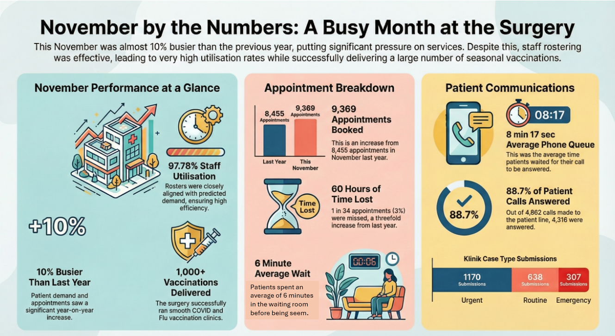

Anne had a query about the phone message, as when she phoned in the afternoon a recorded message said to ring off as it was only available for urgent cases. She just wanted to find out some information. Justin said he would look at the message again.

- Minutes of the last meeting.
These were approved

- Matters arising not dealt with elsewhere.
Graeme was asked if he had made a list of uneven surfaces for wheelchair users. He again explained his problem and was advised to contact the County Council.
Anita said that she was unable to upload the link to CPR and First Aid Training.

- Awareness Week/Event/Grant application.
- Next year’s Awareness Week will be 31st May-6th June. Anne and Anita had discussed holding an event at the end of Awareness Week. The West Sussex ICB has told PPGs that they will be able to apply for a grant of £100-£1000 and details would be available in November. There has now been a delay. We thought we might be able to apply for a grant to cover costs such hiring a hall. Justin said that we could use the surgery and it would be free. Julian volunteered to write our grant application if we decided to apply.
- Several subjects were suggested: CPR, Personal Training, Mental Health, LPA/wills, Healthy Eating, First Aid, Vaccinations, drugs, smoking cessation etc. We agreed to hold an informal meeting in January to discuss this in more detail.
- We thought having such an event would enable us to reach more patients and help us to recruit more members. Justin offered to use AI to produce a poster for the Waiting Room Screen.
- Anne said that she had spoken to a member of staff at the pharmacy and thought that if she was a patient she would be an ideal person to have on the committee.
- Julian spoke about letting patients attend our meeting using Teams. We will investigate this further and will ask Elaine if she would be a guinea pig and try using Teams for our next meeting, especially as she finds it difficult to get to the surgery.
- A.O.B
None

- Date of next meeting: Tuesday 10 February at 6.30pm.
We plan to make this an open meeting with refreshments so that people can observe our Committee Meeting and we would include an open forum for relevant questions.

