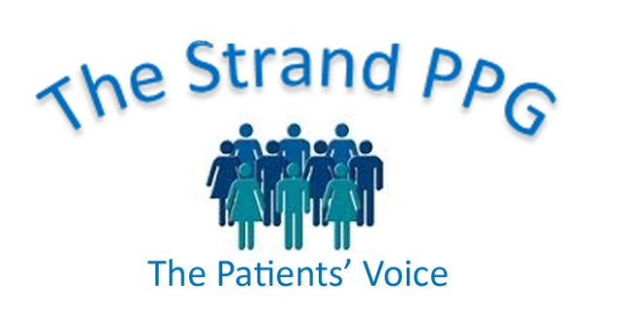

**Strand Patient Participation Group Meeting**

**Tuesday 16 July, 2024**

**Minutes**

**Present:** Shirley, Graeme, Alison, Julian, Anne, Anita, Justin, Sarah

1. **Welcome**

Anita welcomed everyone to the meeting, including Sarah, Head of Reception

1. **Apologies:** none
2. **Minutes of last meeting**

These were approved.

1. **Matters arising not dealt with elsewhere**

Justin will contact LLoyds Bank again about closing our account.

1. **a) Klinik Survey**

Anita and Lorraine had received a few emails from Virtual PPG members about our survey concerning Klinik. They said Klinik was much easier to use but there was concern for older patients who were not on the internet. However, they are urged to continue to phone the surgery. Justin said that they were constantly in touch with Klinik so could change some details though not all are possible. He said the Strand was probably the only surgery in Worthing using Klinik at the moment.

**b) Expanding the Committee**

The newsletter would soon be emailed out and copies will be available at reception. It will contain an appeal for Committee members.

Doctors could be encouraged to ask patients with certain conditions if they would like to be on the Committee.

Anita will email the Virtual PPG Group stating that we need a Chairperson and more Committee members.

**c) AGM: suitable presentation and publicity**

Justin will ask staff this week if someone will give a talk on Diabetes. Once this is confirmed Anita will email the Virtual PPG about this and we will display posters in the Surgery, on the website and on the screen.

We will soon have a new board so that we can display information about the SPPG and it was suggested that we could have posters on the window.

1. **Practice News**

Since introducing Klinik there has been a reduction in phone calls with high demand on Monday, then plateauing out during the week before an increase on Friday. This means that more staff can be available at busier times.

There had been 6100 contacts with Klinik for triage, plus 500 for the Pharmacy Team.

Half were for new problems and 2000 for ongoing problems.

That week there were 122 cases on Monday for the duty team to triage, 20% on the phone and 80% on the web.

Klinik is available from 7.30am so triage can start straightaway.

A new doctor, Dr Byars, has started and another person is interested in joining the practice.

Kim is leaving and Angela will take up the lead role.

All Worthing GP surgeries are now working together in Neighbourhoods.

Place is now the new concept to include East and West Sussex and Brighton and Hove.

Neighbourhoods and Place are an extension to the PCNs and will see the surgery engage with more service providers and lead to the commissioning of some services.

1. **AOB**

None

1. **Date of next meeting**: AGM Tuesday 17 September at 7.00pm.