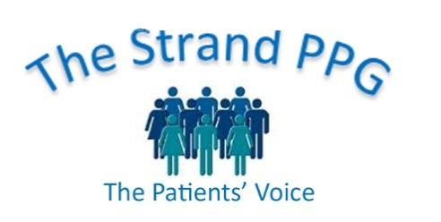

**Strand Patient Participation Group Meeting**

**Tuesday 19 March 2024**

**Minutes**

**Present:** Graeme, Alison, Shirley, Justin, Carol, Anita, Dr Craughan

Apologies: Julian, Wendy, Anne

**Klinik**

1. The meeting started with an update by Dr Craughan on the Klinik online triage system that the surgery will soon be introducing to replace e- consult. By completing the form patients will be directed to the appropriate person or advice. The Klinik form will be available all day long. It needs a few tweaks before being introduced and all staff have to be trained in its use. Where it has been used elsewhere it has brought a 70% reduction in phone calls.

Urgent cases will be dealt with on the day by an appropriate person and response to routine cases will be spread out over a few days.

Information about the new system will be available on the surgery website and leaflets will be available. It will probably start at the beginning of May.

Those who are not online can still phone the surgery but will still go through the same form with the receptionist.

Members were encouraged to look at other surgery websites that have videos explaining the new Klinik system.

After a few months the PPG could ask patients for feedback on using Klinik.

1. **Practice News**

* The clinical pharmacists are carrying out medicine reviews.
* Dr Jarvis is off on 1yr Maternity leave.
* Dr Wyatt will be doing 7 sessions.
* Dr Cheema is joining the practice.
* In February there were 7871 appointments, up 3% on last year.
* There’s an average wait of 4 days to see someone.
* DNAs [Did not attend] was 1%, 2% last year.
* There were 347 appointments outside normal hours, evenings and weekends.
* Covid boosters will soon be available. Patients will be contacted.

1. **Newsletters discussion**

Justin displayed several examples of PPG newsletters and people thought they had too much information to a page and generally questioned the point of the PPG producing a newsletter. It was suggested that we produce a joint newsletter with the surgery about twice a year. We should also have a team to produce the newsletter and not rely on one member.

1. **Dates of next meetings**: Tuesday 14 May and Tuesday 16 July.